Login to AutoRABIT

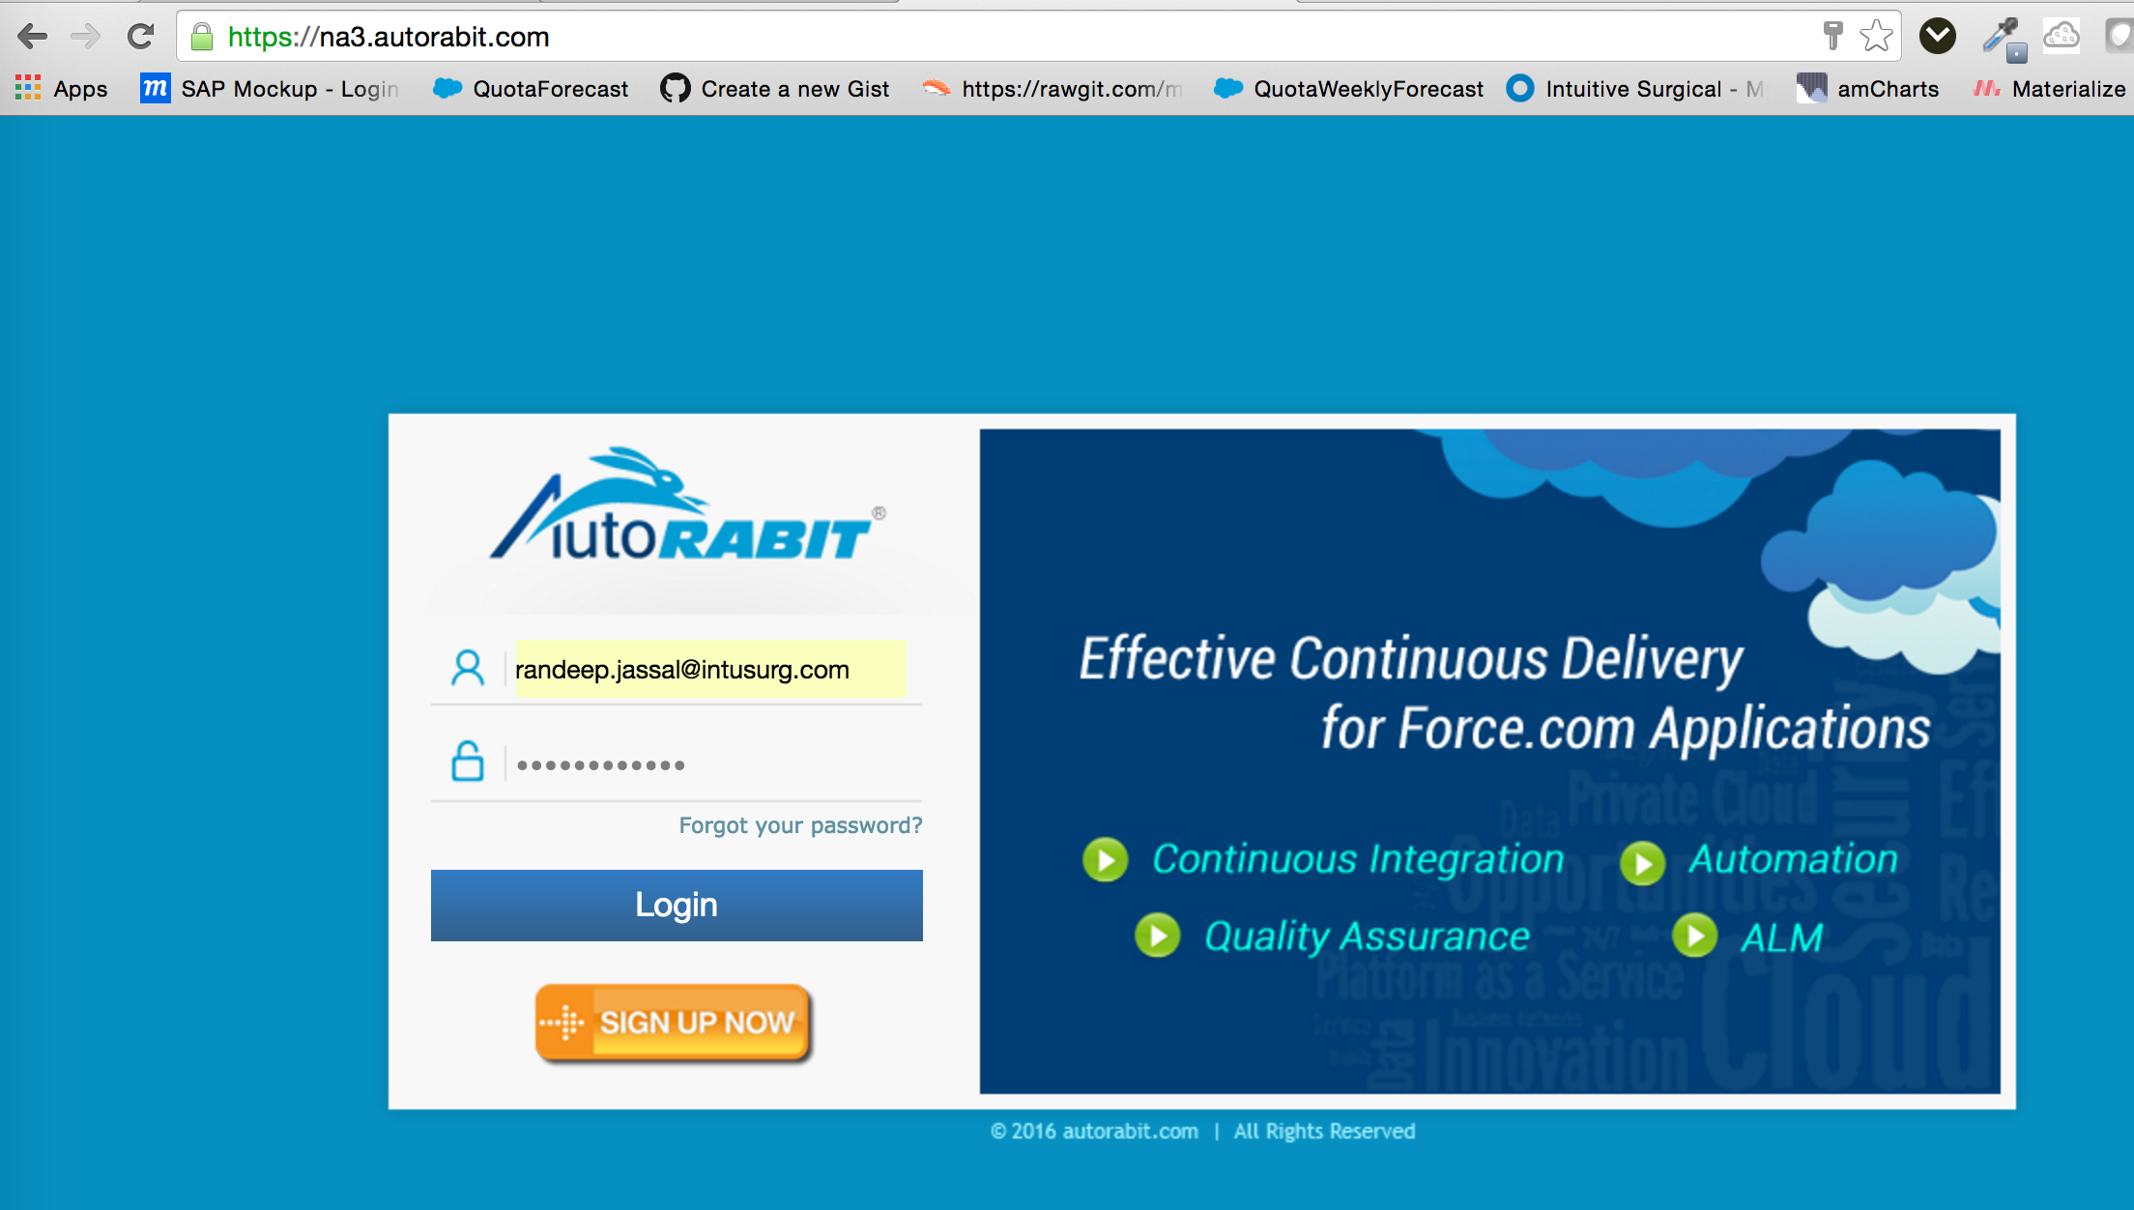

Go to Dataloader

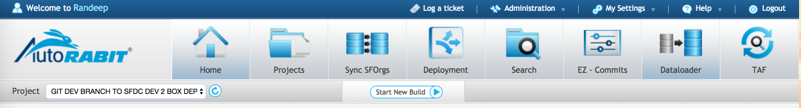

Click on Dataloader Pro

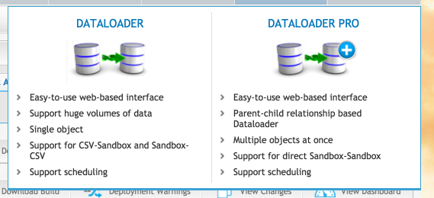

Click on Create Button

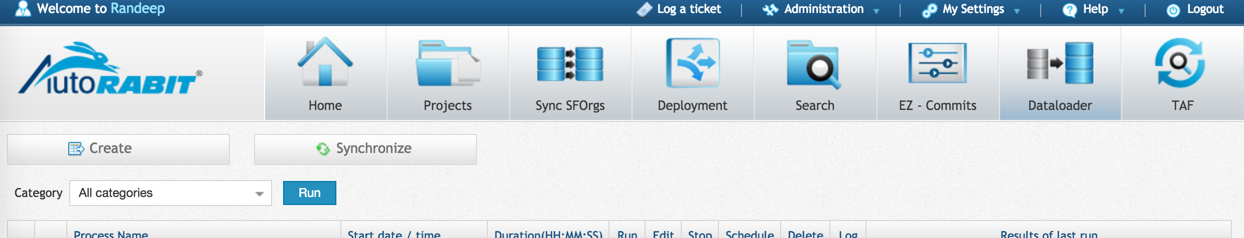

choose the Source and Destination sandboxes

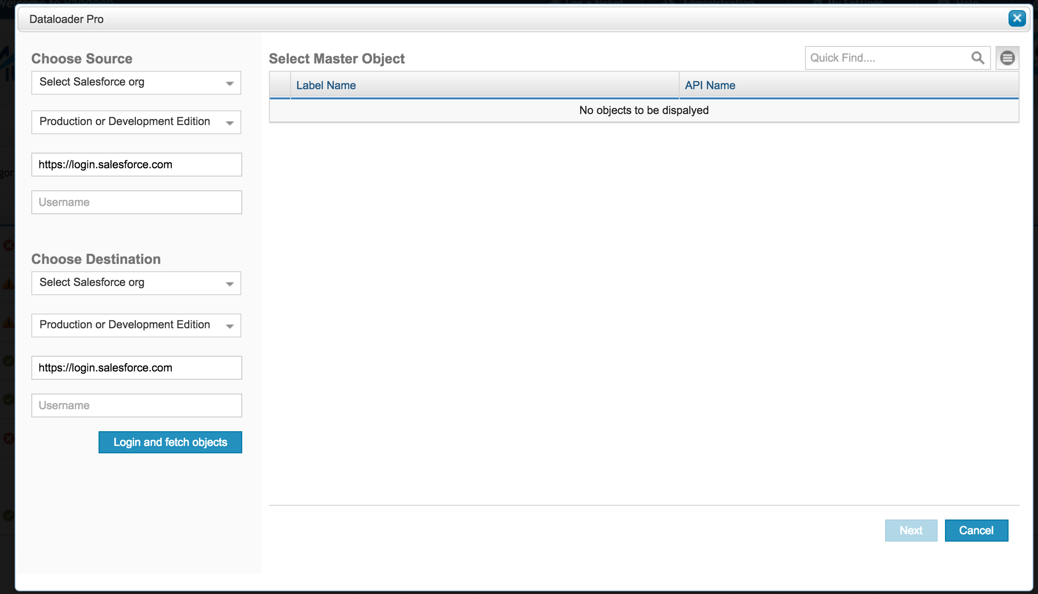

Click on Login and fetch objects and click Next

Select the Object to be migrated and click Next

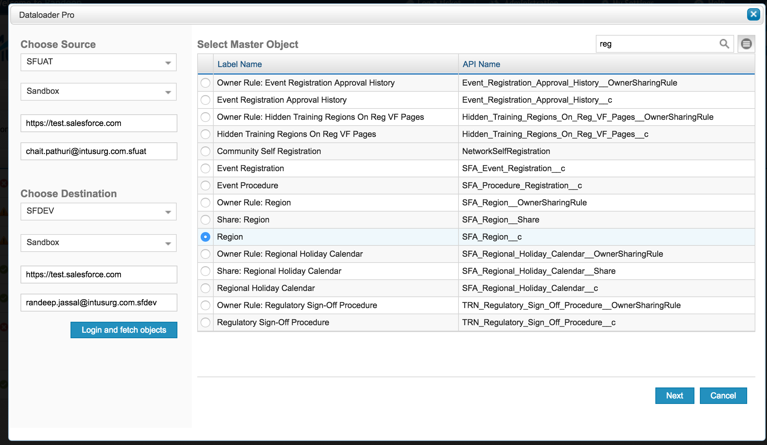

Click Next

And select the children if required and the click Validate Query

And click Next

Name the Process and specify the number of records to be migrated for that object.

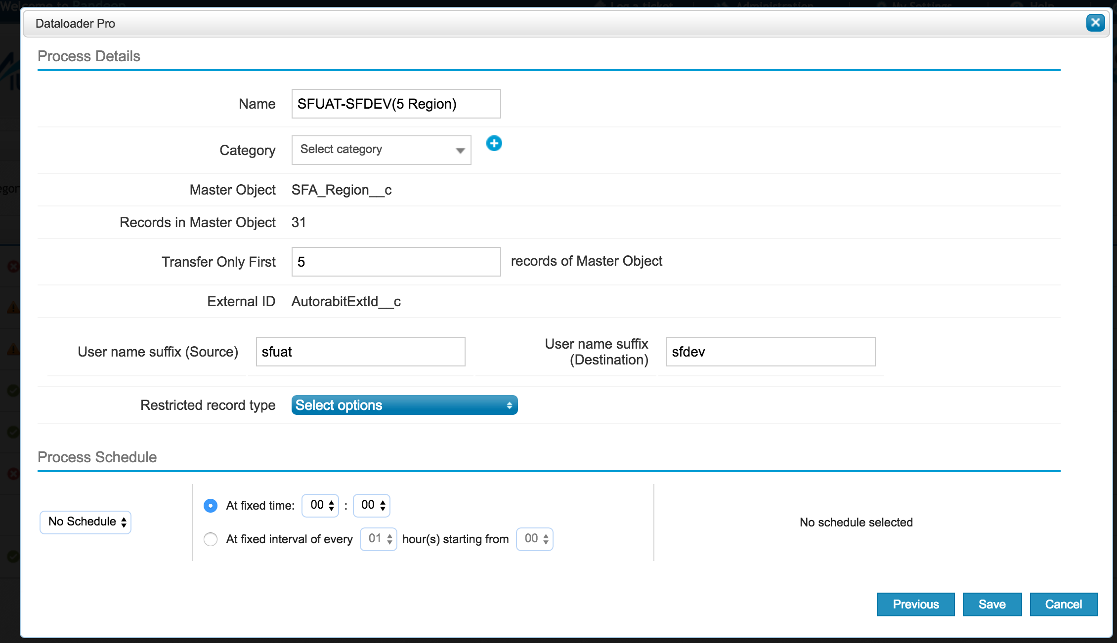

click save and run the process.